PROJECT DESIGN PHASE
AI FAQ Assistant API

Project Name: | AI FAQ Assistant API
Team ID: | SWTID-2026-9625
Date: | 22 September 2026

Design Overview
AI FAQ Assistant API is designed as a modular backend REST API for intelligent FAQ management and question answering. The design separates API routing, request validation, authentication, authorization, business logic, database operations, AI processing, search processing, and feedback management into independent components.
The system uses Node.js and Express.js as the backend platform, MongoDB Atlas as the database, Google Gemini for AI processing, and keyword-based FAQ search for FAQ discovery.
The design follows the MVC pattern with an additional service layer to keep business logic separate from controllers. The AI FAQ Assistant specification describes this layered architecture and identifies the AI FAQ generation and question-answering services as important parts of the backend design.

Design Objectives
The system is designed to:
• Provide secure REST API access
• Separate functionality according to user roles
• Manage the complete FAQ lifecycle
• Maintain relationships between users, FAQs, categories, tags, AI-generated FAQs, and answer feedback
• Integrate Google Gemini for AI FAQ generation and question answering
• Provide keyword-based FAQ search
• Support category and tag-based FAQ discovery
• Protect application resources through authentication and authorization
• Support maintainable and scalable backend development

High-Level System Design
The overall system is divided into the following layers:
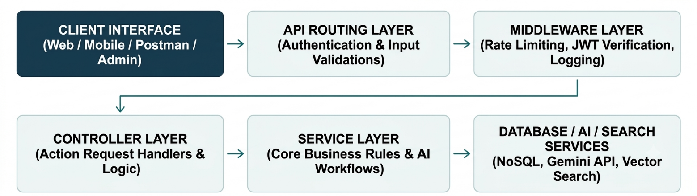

Main Components

API Layer | Security Layer | Business Layer | Data Layer
Authentication APIs User APIs  Blog APIs Category APIs Comment APIs AI APIs  Search APIs | JWT authentication Role authorization Validation Sanitization  Rate limiting | FAQ processing  Category processing  Tag processing  AI processing  Search processing  Feedback processing | Users  FAQs  Categories  Tags  AI Generated FAQs  Answer Feedback

4.Module Design

4.1 Authentication Module
Responsible for:
• User registration
• User login
• JWT generation
• Token verification
• Authenticated-user identification

4.2 User and Role Management Module
Responsible for:
• Maintaining user information
• Maintaining user roles
• Assigning roles through authorized administration
• Enforcing role-based permissions
Supported roles: Admin | Content Creator | User

4.3 FAQ Management Module
Responsible for creating, retrieving, updating and deleting FAQs; managing FAQ status; category assignment; tag management; and content ownership.

FAQ Lifecycle
Create FAQ → Review/Manage FAQ → Update FAQ → Publish/Make Available → Delete FAQ
The AI FAQ Assistant specification defines FAQ lifecycle management and ownership-based access.

4.4 Category Module
Responsible for creating, viewing, updating and deleting categories, and organizing FAQ content.

4.5 Tag Module
Responsible for creating, viewing, updating and deleting tags, and organizing FAQ content using relevant labels.

4.6 AI Module
Responsible for generating FAQ content, generating structured questions and answers, providing AI-powered answers, and processing AI prompts.
Main operations: Generate FAQ | Answer Question
The project specification defines the AI endpoints /api/ai/generate-faq and /api/ai/answer.
4.7 Search Module
The search module provides keyword-based FAQ search:
• Keyword Search - searches FAQ content using words or phrases across questions, answers, categories, and tags.
The AI FAQ Assistant uses keyword-based search. Semantic search, embeddings, and MongoDB Atlas Vector Search are not used in this project.

Database Design
The system uses the following collections:
Users, FAQs, Categories, Tags, AI Generated FAQs, Answer Feedback.

Relationships
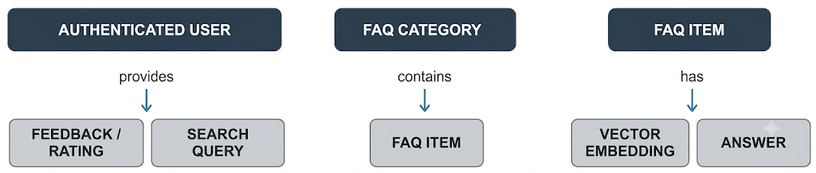A user can create and manage multiple FAQs according to their assigned role. An FAQ can be associated with a category and multiple tags. Users can provide feedback on FAQ answers. AI-generated FAQ information is produced through the Google Gemini API and can be stored for further management.

API Design
The backend is organized into resource-based REST endpoints.

Authentication
POST | /api/auth/register
POST | /api/auth/login
POST | /api/auth/logout
GET | /api/auth/me
Users
GET | /api/users
GET | /api/users/profile
PUT | /api/users/:id
PATCH | /api/users/:id/role
FAQs
POST | /api/faqs
GET | /api/faqs
GET | /api/faqs/:id
PUT | /api/faqs/:id
DELETE | /api/faqs/:id
Categories
POST | /api/categories
GET | /api/categories
GET | /api/categories/:id
PUT | /api/categories/:id
DELETE | /api/categories/:id
Tags
POST | /api/tags
GET | /api/tags
PUT | /api/tags/:id
DELETE | /api/tags/:id
AI
POST | /api/ai/generate-faq
POST | /api/ai/answer
Search
GET | /api/search?q=
GET | /api/search/semantic?q=

AI Design
The AI subsystem is designed as a separate service so that AI processing does not become part of the route or controller logic.
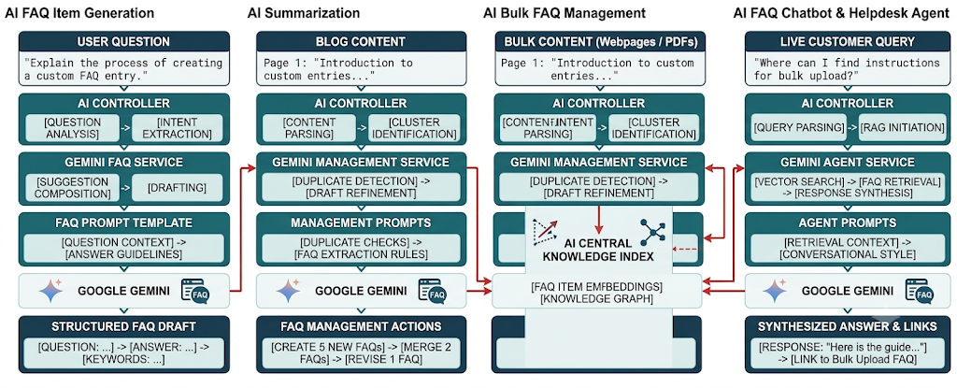

Prompt Design
The system uses structured prompts to control the AI response. For blog generation, the prompt is designed to request:
- Appropriate title
- Structured content
- Summary
- Relevant tags
For summarization, the prompt instructs the model to produce a concise representation of the provided blog content.
This satisfies the Prompt Engineering requirement in the common TN Skills checklist.

Search Design
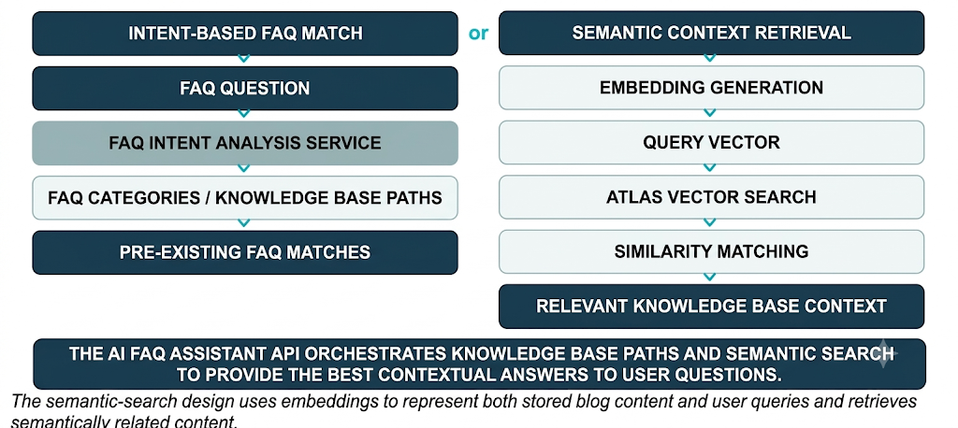The

Security Design
Security is incorporated into the request-processing flow.
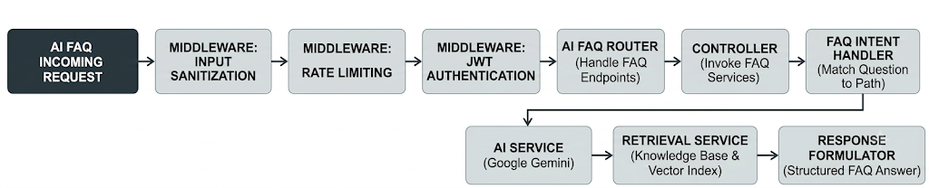Security mechanisms include:
- bcrypt password hashing
- JWT authentication
- Role-based authorization
- Input validation
- Input sanitization
- Rate limiting
- Safe error handling

Data Flow Design

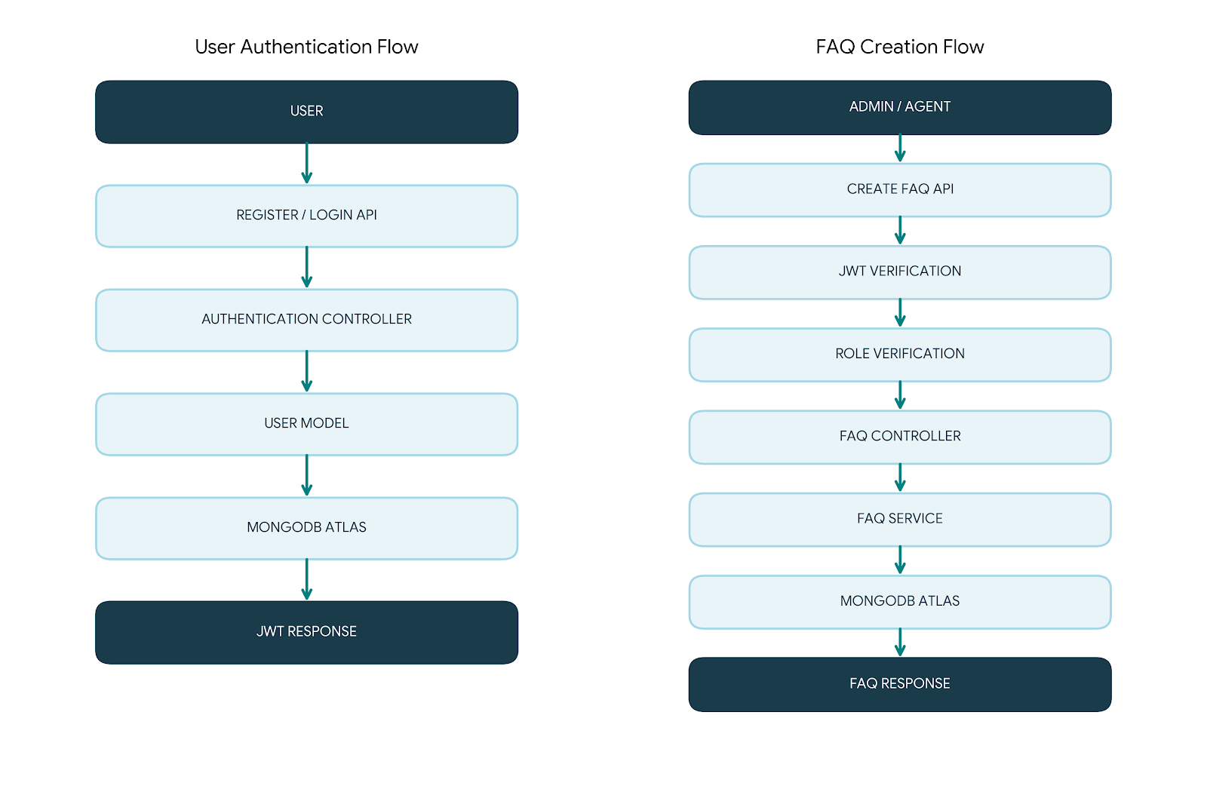

Role-Based Design
The authorization design uses the four project roles.

Role | Main Access
Admin | Complete system management
Editor | Content review, publishing and moderation
Author | Blog creation and own-content management
Reader | Published content and comments
The BlogNest project defines these four roles and their corresponding responsibilities.

Error Handling Design
The system uses centralized error handling. The API returns consistent responses.

Successful Response
{
"success": true,
"message": "Operation successful", "data": {}

Error Response
{
"success": false,
"message": "Operation failed"
}

}
The design ensures that validation errors, authentication failures, authorization failures, missing resources, and server errors are handled consistently.

Scalability Design
The system uses modular components so that each major function can be extended independently.
- AI functionality can be extended with additional Gemini services
- Search functionality can support additional searchable fields
- Additional user roles can be introduced through RBAC
- Additional content-management modules can be added through separate controllers and services
- MongoDB Atlas provides cloud-based database infrastructure

Complete Design Flow
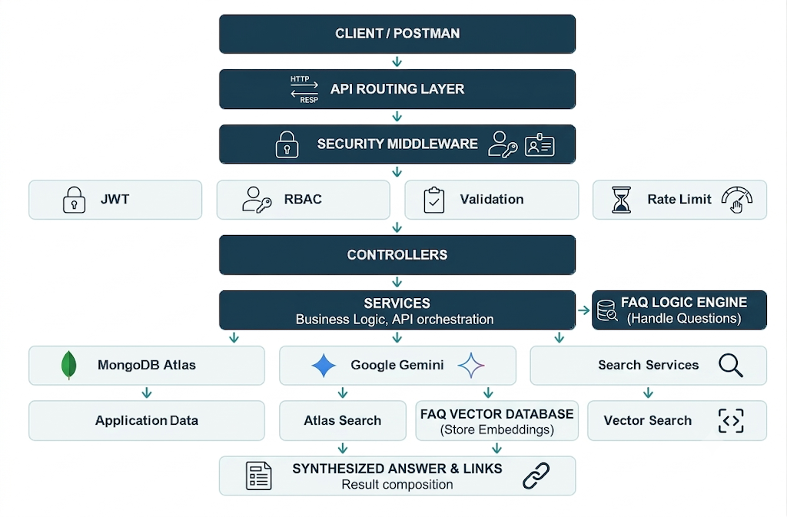

Design Outcome

The final design provides a clear separation between:
• Client interaction
• API routing
• Security
• Business logic
• Database operations
• AI processing
• Search processing
• Feedback management

This design allows AI FAQ Assistant API to function as a secure, modular backend REST API while supporting FAQ management, role-based access control, Google Gemini AI integration, keyword-based FAQ search, and intelligent question answering.

